Figures and Tables
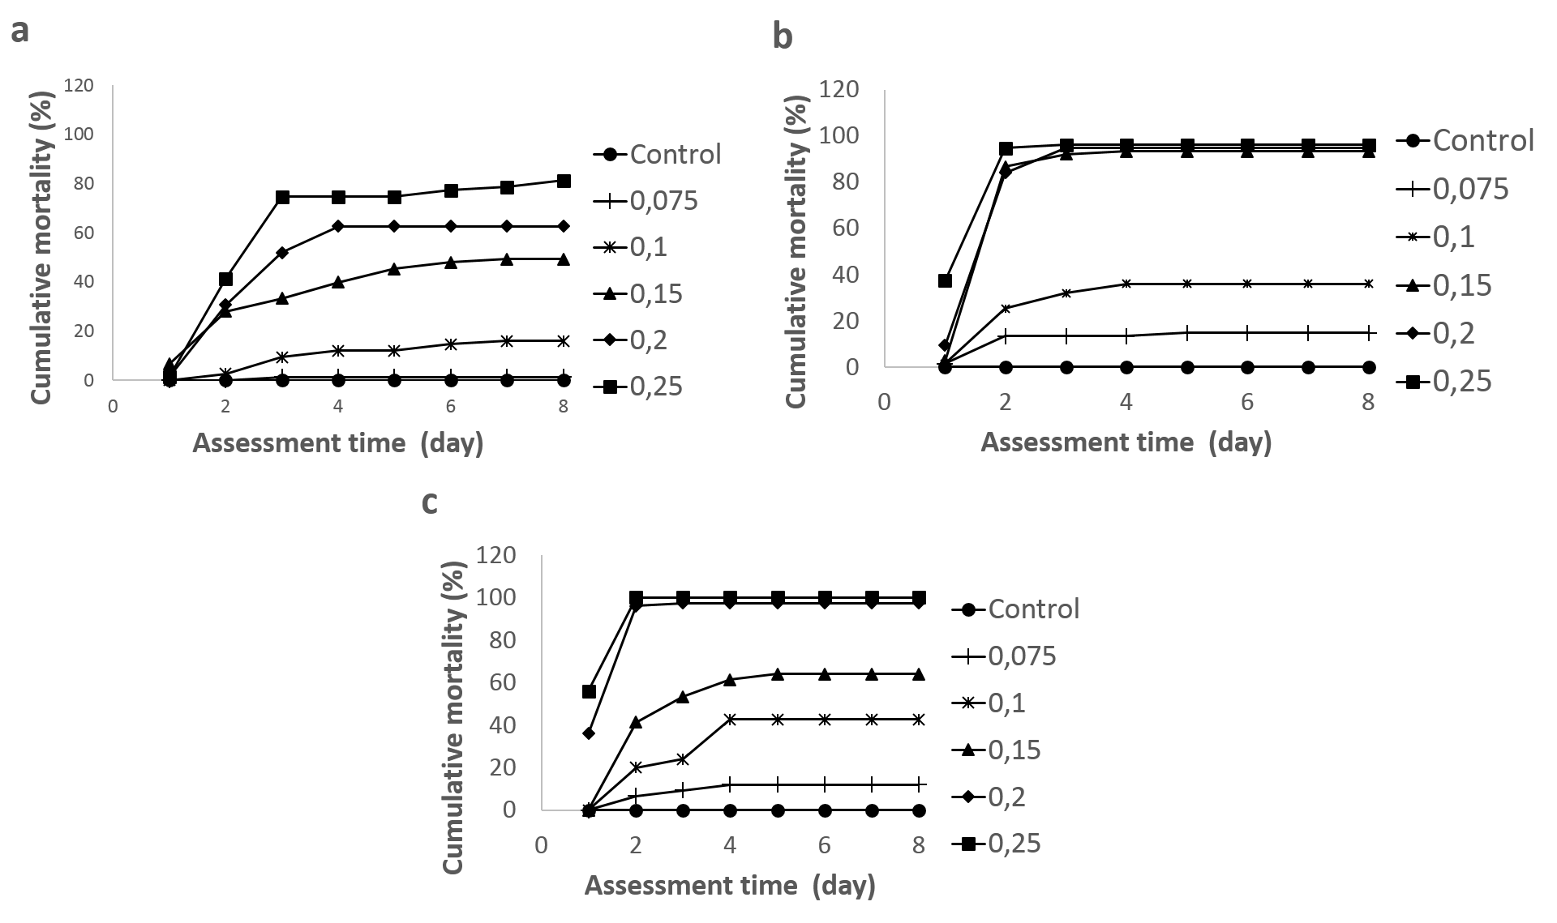

Figure 1. Time-course mortality of C. pavonana larvae caused by EC formulation mixture of T. vogelii and P. aduncum (1:5) after stored during 90 days in condition: a). Room temperature, b). temperature under 4ºC, dan c). 40ºC temperature.
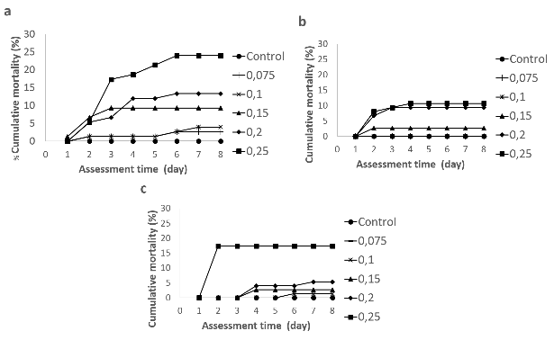

Figure 2. Time-course mortality of C. pavonana larvae caused by WP formulation mixture of T. vogelii and P. aduncum (1:5) after stored during 90 days in condition: a). Room temperature, b). temperature under 4ºC, dan c). 40ºC temperature

Table 1. Duration ofC. pavonana larval development cause by 20 EC and 20 WP T. vogelii and P. aduncum (1: 5) Formulations after 90 days storedin various temperatures
Storage Condition | Formulation  Concentration (%) | Mean duration ± SD (days)
 |  | EC Formulation |  | WP Formulation
 |  | Instar 2-3 | Instar 2-4 | Instar 2-3 | Instar 2-4
Below 4ºc Temperature | Control (0) | 2 ± 0 | 3.93 ± 0.55 | 2 ± 0 | 3.48 ± 0.55
 | 0.075 | 3.11 ± 0.59 | 4.87 ± 0.42 | 2.49 ± 0.81 | 4.35 ± 0.48
 | 0.1 | 3.37 ± 0.86 | 5.42 ± 1.18 | 2.67 ± 0.76 | 4.33 ± 0.48
 | 0.15 | 4.5 ±1 | 6.75 ± 0.5 | 2.95 ± 0.79 | 4.65 ± 0.56
 | 0.2 | 5 ± 1 | 6.67 ± 0.57 | 2.88 ± 0.72 | 4.78 ± 0.73
 | 0.25 | 4 ± 0 | 6 ± 0 | 3.42 ± 0.67 | 5.26 ± 0.69
Room Temperature | Control (0) | 2.09 ± 0.37 | 3.93 ± 0.55 | 2 ± 0 | 3.48 ± 0.55
 | 0.075 | 3.19 ± 0.43 | 5.15 ± 0.56 | 2.76 ± 0.45 | 3.66 ± 0.77
 | 0.1 | 3.52 ± 0.59 | 5.22 ± 0.45 | 2.37 ± 0.64 | 4.32 ± 0.49
 | 0.15 | 4.37 ± 0.63 | 5.79 ± 0.77 | 2.39 ± 0.67 | 4.26 ± 0.56
 | 0.2 | 4.11 ± 0.78 | 5.82 ± 0.67 | 3.05 ± 0.78 | 4.84 ± 0.64
 | 0.25 | 4.78 ±0.80 | 6.36 ± 0.84 | 2.61 ± 0.77 | 4.33 ± 0.57
40ºC Temperature | Control (0) | 2.01 ± 0.11 | 3.91 ± 0.29 | 1.92 ± 0.27 | 3.83 ± 0.99
 | 0.075 | 3.03 ± 0.58 | 5.11 ± 0.66 | 2.13 ± 0.34 | 4.12 ± 0.33
 | 0.1 | 3.47 ± 0.69 | 5.79 ± 0.84 | 2.41 ± 0.59 | 4.64 ± 0.81
 | 0.15 | 3.88 ± 0.75 | 6.52 ± 0.94 | 2.40 ±0.59 | 4.65 ± 0.81
 | 0.2 | - | - | 3.04 ± 0.80 | 4.66 ± 0.84
 | 0.25 | - | - | 4.03 ± 1.11 | 5.89 ± 1.09

Table 2. Parameter of probit regression for relationship 20 EC and 20 WP of T. vogelii:P. aduncum(1:5) formulations and mortality of C. pavonana larvae

Treatment | Storage Temperature | b +SE^{a)} | LC₅₀ (CI 95%) | LC₉₅ (CI 95%)
EC Formulations | Below 4ºC | 6.38 + 0.54 | 0.11 (0.08-0.14) | 0.19 (0.15-0.44)
 | Room temperature | 4.92 + 0.46 | 0.16 (0.14-0.18) | 0.34 (0.28-0.50)
 | 40ºC | 6.32 + 0. 54 | 0.11 (0.08-0.14) | 0.21 (0.16-0.42)
WP formulations | Below 4ºC | 3.81 + 1.13 | 0.49 (0.35-1.72) | 1.33 (0.66-18.26)
 | Room temperature | 2.38 + 0.55 | 0.53 (0.34-2.80) | 2.59 (1.10-24.08)
 | 40ºC | 3.80 + 0.99 | 0.47 (0.34-1.14) | 1.27 (0.67-8.92)
^{a)}b = slope, SE= standard error, CI= Confidence Interval

