Flowering and Fruiting Phenology of Rubus spp. in Cibodas Botanical Garden, Indonesia

Muhammad Imam Surya and Wiguna Rahman

Cibodas Botanical Garden – Indonesian Institute of Sciences

Po. Box. 19 SDL, Cipanas – Cianjur 43253 West Java, Indonesia
Corresponding author: phone: +62-263-512233; e-mail: muhammad.imam.surya@lipi.go.id

Abstract
Flowering and fruiting phenology were studied in five species of Rubus spp (Rubus ellipticus, Rubus fraxinifolius, Rubus lineatus, Rubus moluccanus, and Rubus pyrifolius) which collected in Cibodas Botanical Garden. It has occurred since April 2009 to March 2010. Flowers and flower buds was produced every month by Rubus spp., but they produced difference amount. Furthermore, number of fruits was also shown a different in each species. This results show that each species has a different response to environment.

Keywords: Rubus, Phenology, Cibodas Botanical Garden

INTRODUCTION
Cibodas Botanical Garden is an institute of ex situ conservation where located in forest complex of Mounts Gede Pangrango, Cianjur, West Java, Indonesia. Gardens that has a wide area 84,99 hectare was established on 1852. This garden has hilly and undulating topography with an altitude around 1300 – 1425 m above sea level. Rubus spp is one of genera which collected in Cibodas Botanical Garden.
Rubus is distributed from the low land tropics to subarctic region and also found on all continents except Antarctica (Focke, 1910, 1911, 1914; Thompson, 1995; Yang and Pak, 2006). In Malesia Region, there are 46 species of Rubus, and 25 of them was found in Indonesia (Kalkman, 1993). Currently, Cibodas Botanic Gardens has been collected eight species, such as R. alpestris, R. chrysophyllus, R. ellipticus, R. fraxinifolius, R. lineatus, R. molaccanus, R. pyrifolius, and R. rosifolius. Some of them were collected from mountains of Indonesia (Surya, 2009).
Phenology is the study of the timing of recurring biological events, the causes of their timing with regard to biotic and abiotic forces, and the interrelation among phases of the same or different species (Lieth, 1974), and it is one of interesting topic in the tropical. The phase may be first flowering date, bud break, unfolding of first leaf, etc. Factors influencing phenology vary by species, but include photoperiod, soil moisture, soil temperature, air temperature, solar illumination (Reed et al. 1994).
This research was aimed to observe the phenology of flowering and fruiting of Rubus spp. which is collected in Cibodas Botanical Garden.

MATERIALS AND METHODS
Flowering and fruiting phenology was observed on five species of Rubus spp. which collected in Cibodas Botanical Garden. There are Rubus ellipticus, Rubus fraxinifolius, Rubus lineatus, Rubus moluccanus, and Rubus pyrifolius. This research was done in Cibodas Botanical Garden, West Java – Indonesia, from April 2009 to March 2010. Phenological data were recorded weekly. A rank scale was used to observe the abundance of flower buds, flowers and fruits. Scores were: 0 = absent, 1 = low (less than 25% of canopy), 3 = medium (25 – 50 % of canopy), and 5 = high (more than 50% of canopy). The value scale of phenological events (in months) was calculated by the average of scale each week for all events and species. Others data such as temperature and relative humidity were obtained from the data of Cibodas Botanical Garden. Pearson correlation analysis (Gomez and Gomez, 1995) was conducted to determine whether there was a relationship between environment (temperature and relative humidity) and the average scale of phenological events.

RESULTS AND DISCUSSION
Reproductive phenology was observed on five species of Rubus spp. Generally, the results showed that each species has different phenological cycles. Production of flower buds on Rubus ellipticus occurred every months and the maximum production was obtained on October to November. This period was the same with the maximum of fruit production. Moreover, this phenomena might be related with the environment especially temperature. Using correlation analysis, the result showed that the maximum temperature has a negative correlation with flower buds and fruiting time (Table 1). It means that on October and November while the maximum temperature was going down, it might be stimulate this species to product flower buds and fruits.

Table 1. Correlation value of Rubus spp. between reproductive events, temperatures and relative humidity
Variables |  | Max. Temp. | Min. Temp. | Average Temp. | Relative Humidity
R. ellipticus | Flower buds | -0.587* | -0.020 | -0.537 | 0.032
 | Flowering | -0.145 | 0.321 | -0.058 | -0.121
 | Fruting | -0.528 | 0.188 | -0.437 | -0.070
R. fraxinifolius | Flower buds | 0.428 | -0.081 | 0.372 | -0.080
 | Flowering | 0.239 | 0.391 | 0.307 | 0.582*
 | Fruting | -0.261 | 0.222 | -0.186 | 0.965**
R. lineatus | Flower buds | -0.314 | -0.431 | -0.384 | -0.481
 | Flowering | 0.575 | -0.431 | 0.423 | -0.619*
 | Fruting | 0.761** | 0.403 | 0.783** | -0.306
R. moluccanus | Flower buds | -0.490 | -0.427 | -0.541 | -0.279
 | Flowering | 0.324 | 0.256 | 0.354 | -0.137
 | Fruting | -0.075 | -0.222 | -0.118 | 0.617*
R. pyrifolius | Flower buds | -0.488 | -0.580* | -0.575 | 0.332
 | Flowering | -0.583* | 0.091 | -0.509 | 0.243
 | Fruting | -0.398 | 0.347 | -0.281 | 0.315
*=P<0.05 (critical value: 0,576); **=P<0.01 (critical value: 0,708)
Rubus fraxinifolius that called ‘Arben’ has different reproductive event comparing with Rubus ellipticus, which is the maximum of fruit production occurred from January to March. Moreover, flower buds and flowers production obtained on June and January. Furthermore, the result showed that fruiting event of Rubus fraxinifolius has a positive correlation with relative humidity (0.965**). Figures 1 and 2 (Rubus faxinifolius) showed that the increasing of relative humidity was followed by the production of fruit.

Figure 1. Monthly relative humidity, minimum and maximum temperatures from Cibodas Botanical Garden

Rubus lineatus is a species that able to produce fruit throughout the year. The results showed that the maximum production of fruit occurred on June while the maximum temperature was around 30 ºC. This species might be similar with the others tropical tree, which reported by Tutin and Fernandez (1993) and Chapman et al. (1999) that the temperature may act directly to fruiting phenology. Moreover, pearson correlation analysis also supported this result, which is fruiting event has a positive correlation with a maximum temperature (0.761**). Furthermore, the maximum production of flower buds was obtained on August. In another hand, correlation analysis showed that flowering events had a negative correlation with relative humidity (-0.619*). It means that the production of flowers would be increasing while relative humidity was going down. Figures 1 and 2 (Rubus lineatus) showed clearly that the maximum production of flower occurred on July while the relative humidity was low.
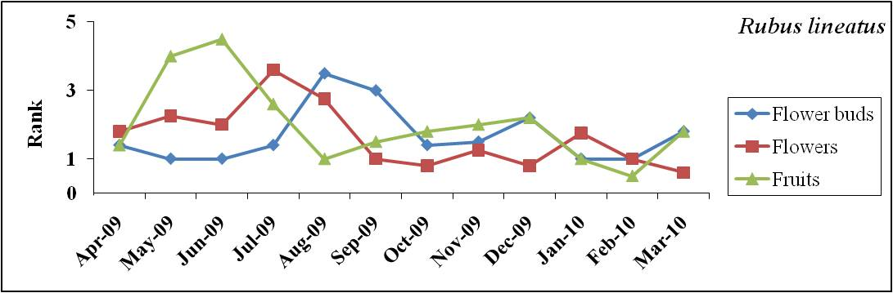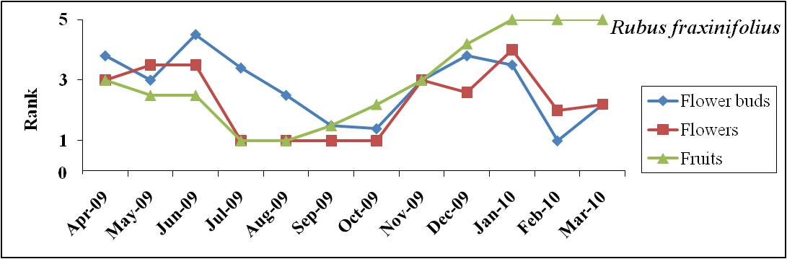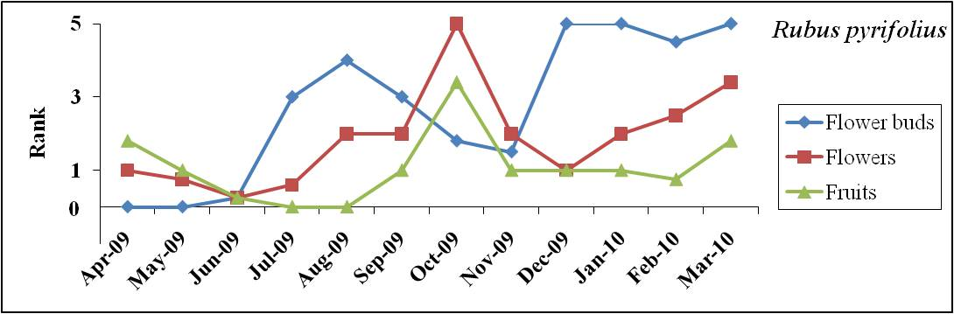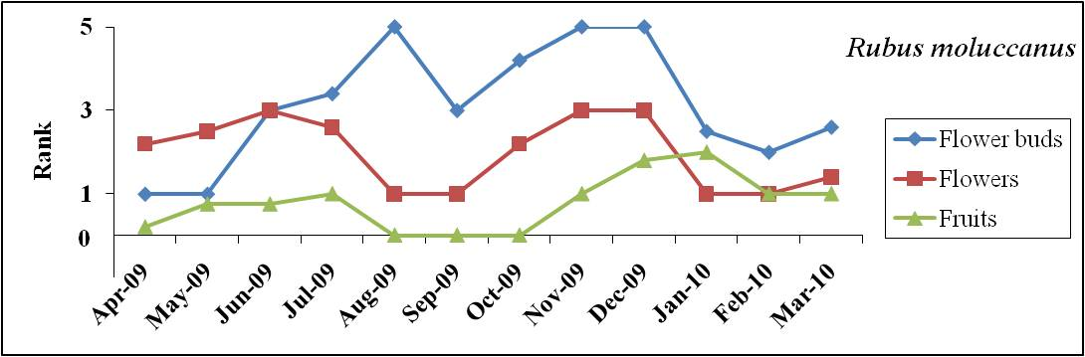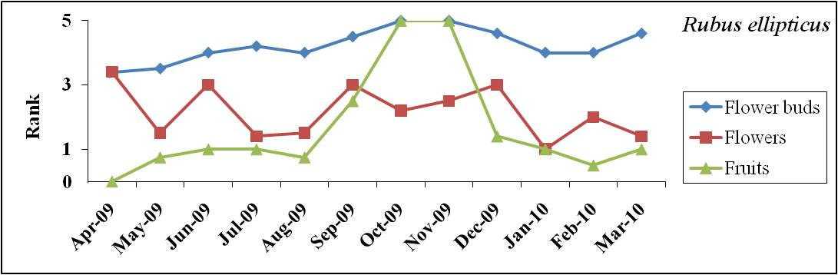

Figure 2. Phenology of reproductive events of Rubus spp. at Cibodas Botanical Garden
Flower buds and flowers production of Rubus moluccanus occurs simultaneously. The maximum production occurred on August, November, December (Flower buds) and June, November, December (Flowers). Fruits production of Rubus moluccanus was not occur throughout the year. Figure 2 showed that fruits production was obtained on November to March and continue from May to July. The maximum of fruit production occurred on January. Comparing with the others species, this species has a lowest fruit production. Furthermore, the graph for Rubus moluccanus on figure two showed that not all of flower buds became a flower and also not all of flowers became a fruits. This phenomenal is almost the same as Rubus ellipticus. The others environment factors such as pollinator, rain fall, or fertilizers may influence in this species. Bown and Mcneil (2009) reported that seed set and also fruit production of Rubus was influenced by insect. Pollination by insects is common, Hippa and Koponen (1976) have been identified pollinators in Rubus.
Rubus pyrifolius is one of species that not produce fruits throughout years. The maximum production occurred on October, and during July to August, this species was not produce a fruit. Furthermore, the maximum production of flowers occurred in the same months like a fruit production. Even though the time of maximum production was the same, but there is no zero production of flowers like as the fruits. Production of flowers occurs simultaneously throughout years. This phenomena indicated that this species may has the others factors that influences the fruiting phenology. In the other hand, Table one showed that flower buds and flowering event has a negative correlation with temperature. Moreover, the maximum production of flower buds and flowers was obtained on December to January, and October.

CONCLUSIONS
Almost all the species, except Rubus pyrifolius, production of flower buds and flowers occurred throughout years. Moreover, Rubus fraxinifolius and Rubus lineatus are able to produce flower buds, flowers and also fruits throughout years. Relative humidity is an environment factor that influences a fruiting phenology in Rubus fraxinifolius and Rubus moluccanus. Furthermore, temperature was influences a reproductive event in Rubus ellipticus, Rubus lineatus, and Rubus pyrifolius.

ACKNOWLEDGEMENTS
This study was supported by Cibodas Botanical Garden, Indonesian Institute of Sciences, Indonesia.

REFERENCES
Brown, A.O. and Mcneil, J.N. 2009. Pollination ecology of the high latitude, dioecios cloudberry (Rubus chamaemorus; Rosaceae). American Journal of Botany 96 (6): 1096-1107.
Chapman , C.A., Wrangham, R.W.W., Chapman, L.J., Kennard, D.K. and Zanne, A.E. 1999. Fruit and flower phenology at two sites in Kibale National Park, Uganda. Journal of Tropical Ecology 15: 189–211.
Focke, W.O. 1910. Species Ruborum monographiae generic Rubiprodromus. Bilb Bot 17: 1–120.
Focke, W.O. 1911. Species Ruborum monographiae generic Rubiprodromus. Bilb Bot 17: 121–223.
Focke, W.O. 1914. Species Ruborum monographiae generic Rubiprodromus. Bilb Bot 19: 224–498.
Gomez, K.A. and Gomez, A.A. 1995. Statistical procedur for agriculture research. second eds. Translated by E. Sjamsuddin dan J.S. Baharsjah. Universitas Indonesia Press. 698 pp.
Hippa, H. and Koponen, S. 1976. Preliminary studies on flower visitors to and potential pollinators of the cloudberry (Rubus chamaemorus L.) in subartic Lapland. Annales Agriculturae Fenniae 15: 56–65.
Kalkman, C. 1993. Rosaceae. Flora Malesiana ser. I. vol. 11(2): 227–351. Leiden University.
Lieth, H. (ed.) 1974. Phenology and seasonality modelling. Ecological studies 8, 209-214. Springer.
Reed, B.C., Brown, J. F., VanderZee, D., Loveland, T. R., Merchant, J. W. and Ohlen, D. O. 1994. Measuring phenological variability from satellite imagery. Journal of Vegetation Science. 5: 703-714.
Surya, M.I. 2009. Diversity and Economic Potency of Rubus spp. Collection of Cibodas Botanical Garden (Keanekaragaman dan Potensi Ekonomi Rubus spp. Koleksi Kebun Raya Cibodas). Warta Kebun Raya Vol. 9(1): 21–26.
Thompson M.M. 1995. Chromosome numbers of Rubus species at the National Clonal Germplasm Repository. HortScience 30: 1447-1452.
Tutin, C.E.G. and Fernandez, M. 1993. Relationships between minimum temperature and fruit production in some tropical forest tree in Gabon. Journal of Tropical Ecology 9: 241–248.
Yang, J.Y. and Pak. J.H. 2006. Phylogeny of Korean Rubus (Rosaceae) Based on ITS (nrDNA) and trnL/F Intergenic Region (cpDNA). Journal of Plant Biology 49(1): 44–54.

